MySQL Assignment 1 – DDL Commands & Constraints
1. Table Creation (CREATE):
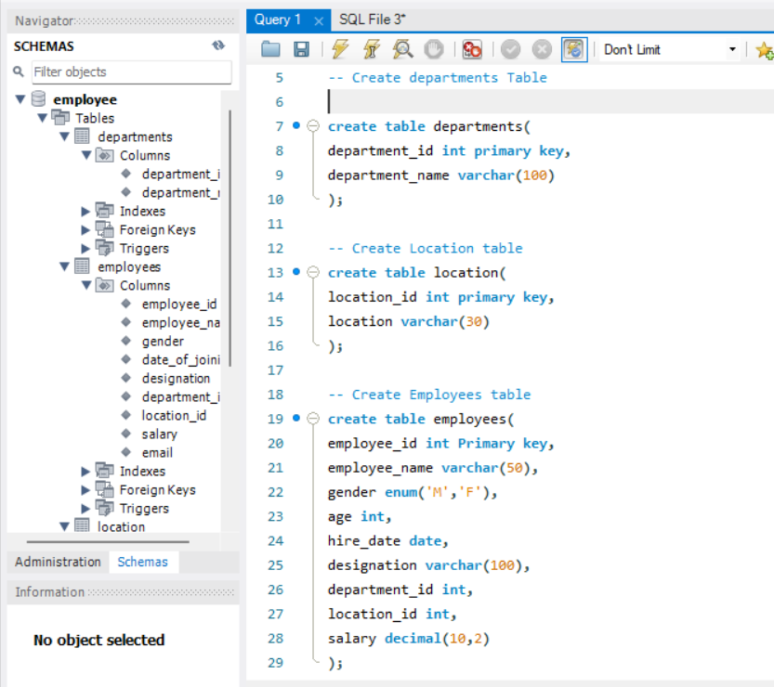

2. Table Alteration (ALTER):
3. Table Renaming (RENAME):
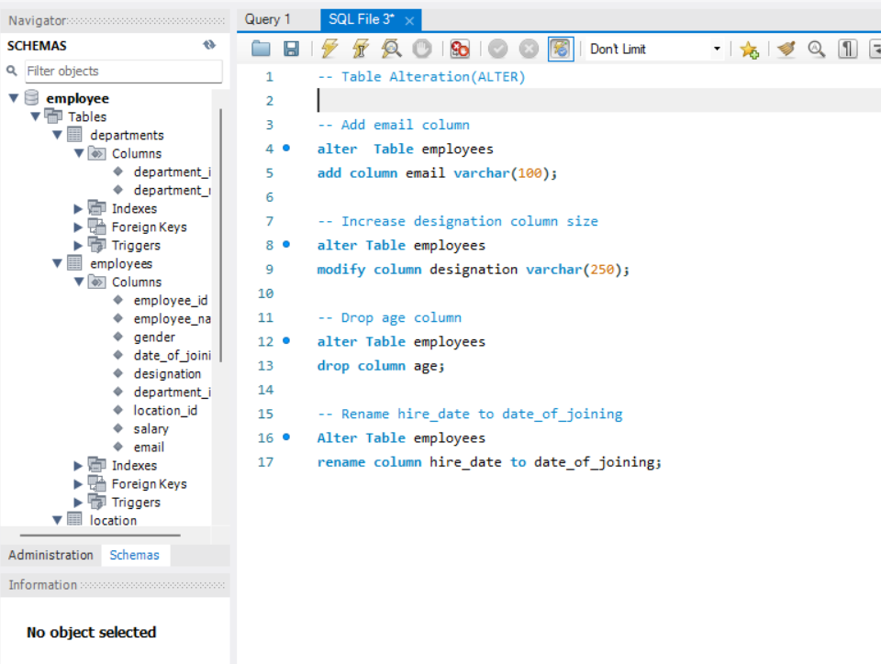

4. Table Truncation (TRUNCATE): Write an SQL statement to truncate the
Employees table.
5. Database & Table Dropping (DROP): Write the SQL statements to drop the
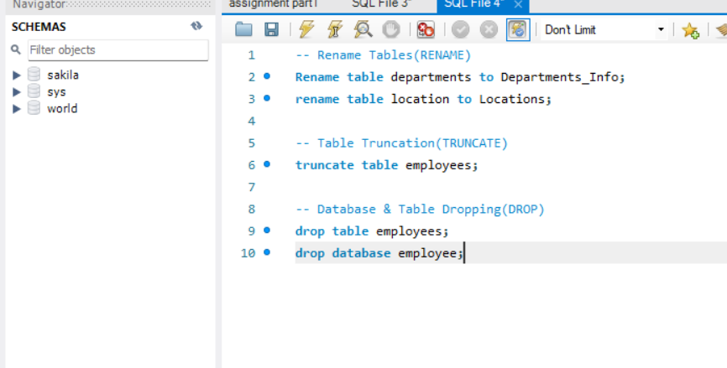
Employees table and then the “employee” database.

Constraints :

